**Demo 3**

**How to Create a Thermometer Chart**



**Steps to be followed:**

**Step 1: Open the Excel file**

* 1. Open the file named **Chart.xlsx** and click on the **Thermometer Chart** worksheet

**Step 2: Creating a chart**

2.1 Choose cell C22 in the sheet



2.2 In the Insert tab, choose **Clustered Column** chart for the data

2.3 The chart looks like the following:

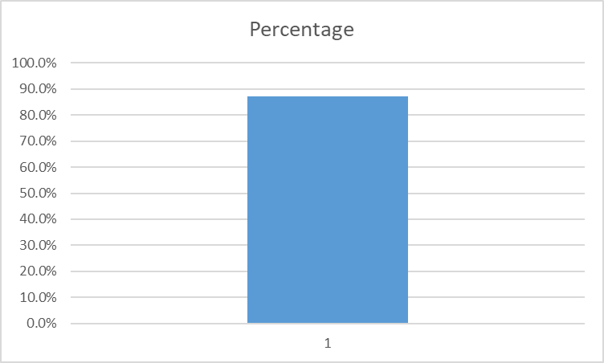

2.4 Right click on the chart and select **Format Data Series**

2.5 Change the **Gap Width** to **0%**

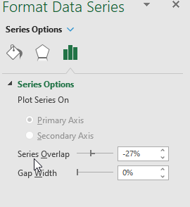

2.6 Resize the chart to be narrower

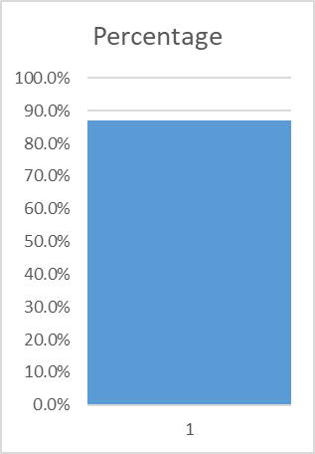

2.7 Right-click on the vertical axis and choose **Format Axis**

2.8 Change Minimum to **0.8** and Maximum to **1** in the Bounds

2.9 Right-click on the bar and change color to **Red**

2.10 Right-click on the top part of the bar and click **Fill**

2.11 Change the fill color to **black**

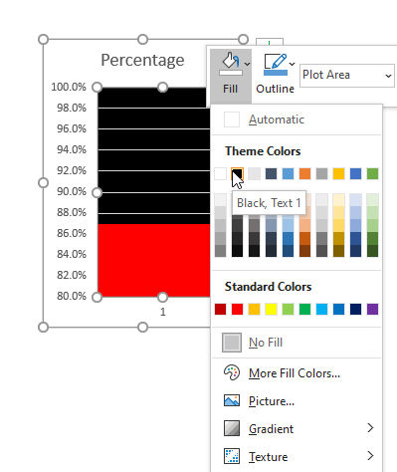

2.12 Insert an **oval shape** by going to **Shapes** under the Insert tab

2.13 Change the fill color of the oval to **Red**

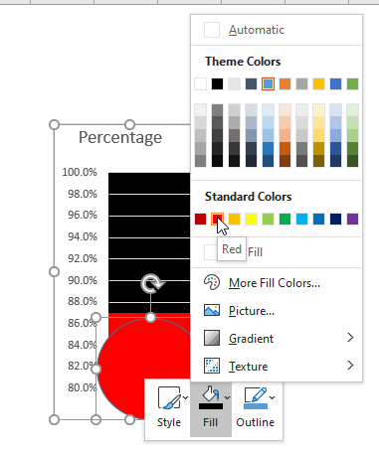

2.14 Change the **Outline** color of the oval to **Red**

2.15 The final thermometer chart looks like the following:

